# Happy path

## Create test song metadata (200)

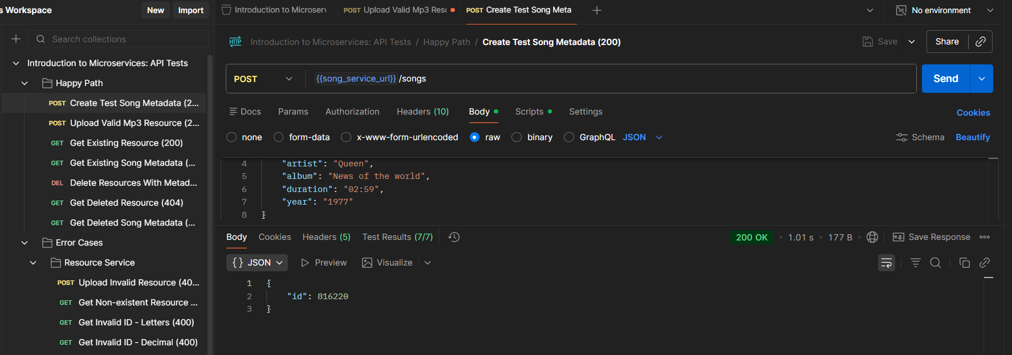

## Upload Valid Mp3 Resource (200)

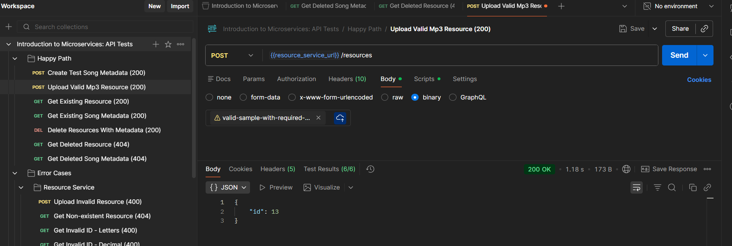

## Get existing resource (200)

## Get existing song metadata (200)

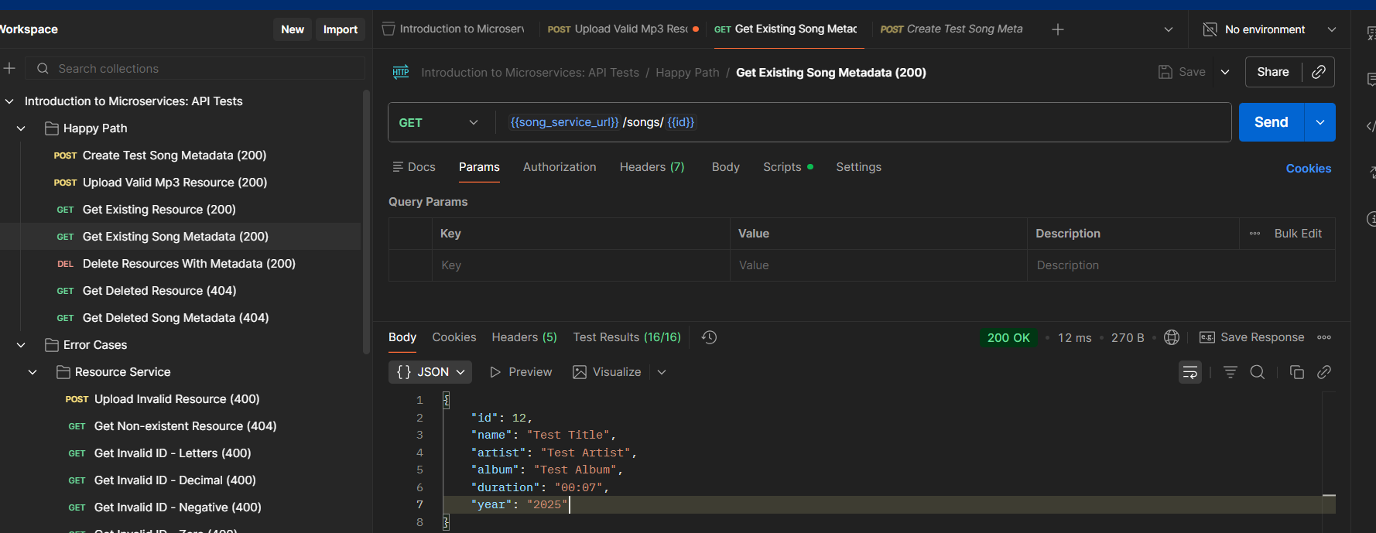

## Delete resources with metadata (200)

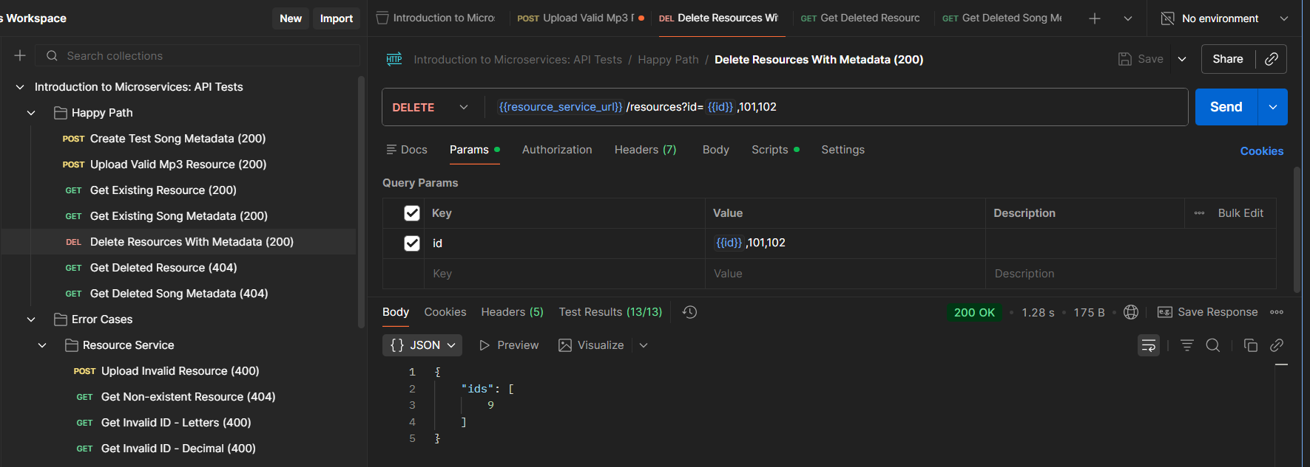

## Get deleted resource (404)

## Get deleted song metadata (404)

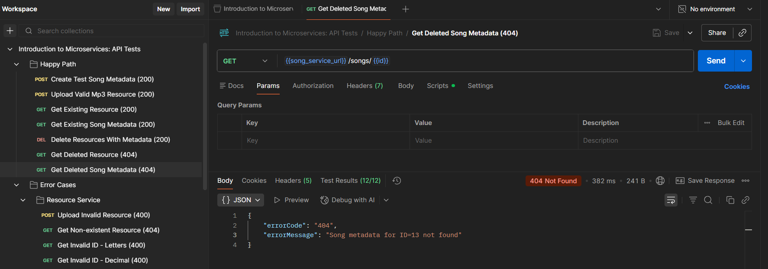

# Error cases: Resource Service

## Upload invalid resource (400)

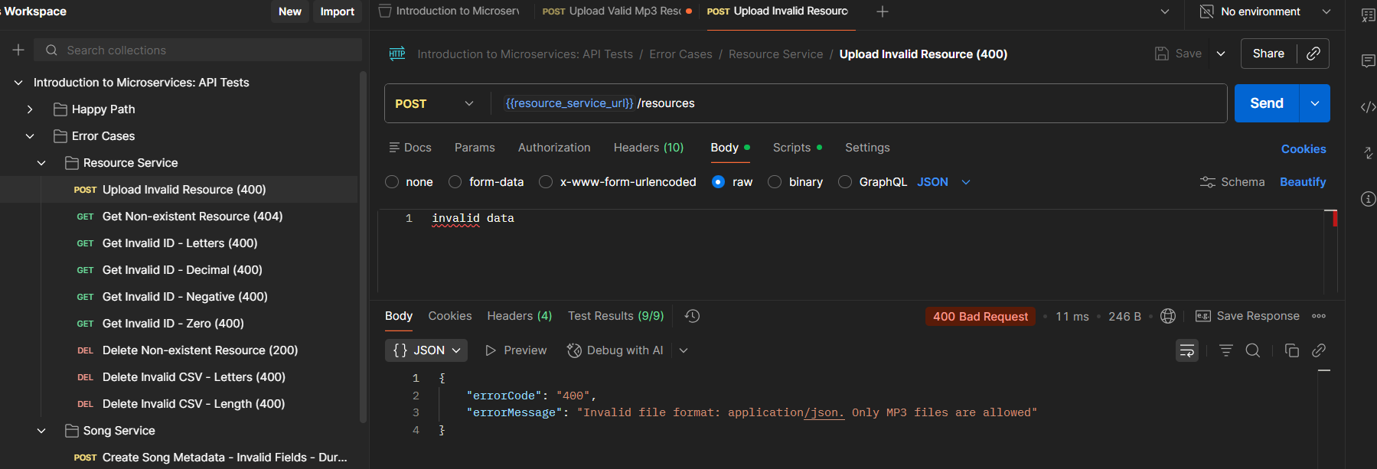

## Get non-existent resource (404)

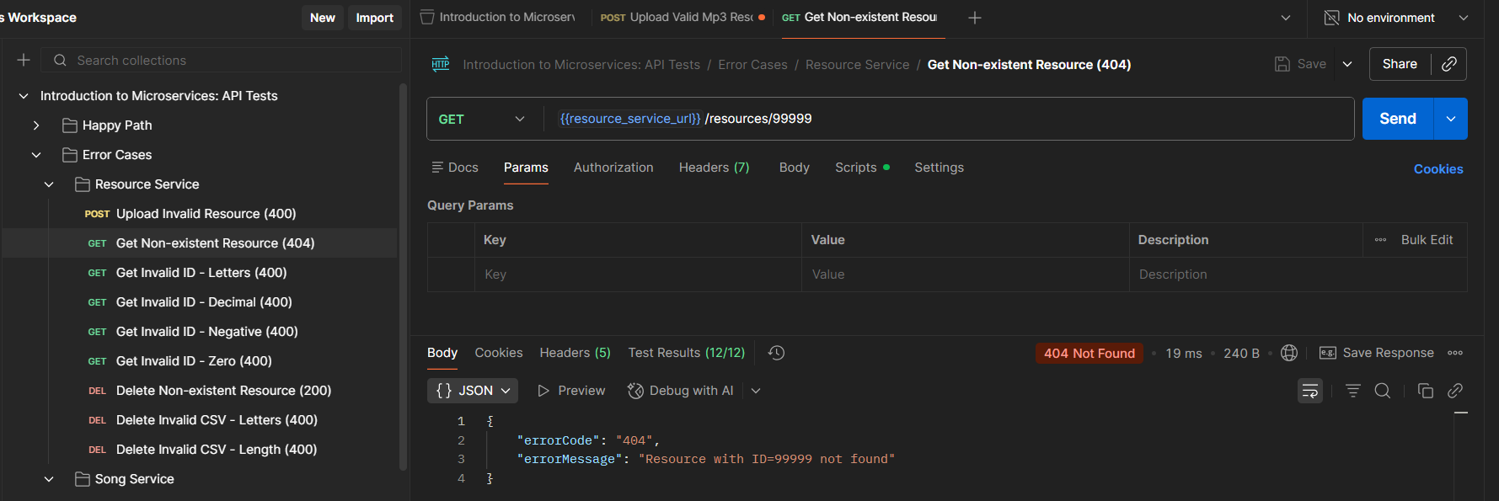

## Get invalid ID - letters (400)

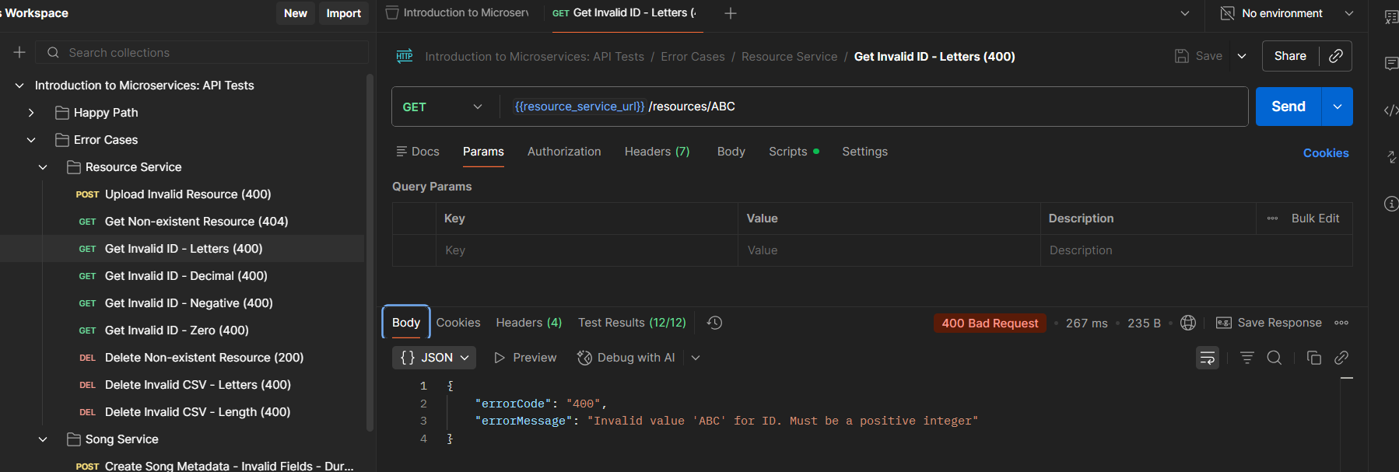

## Get invalid ID - decimal (400)

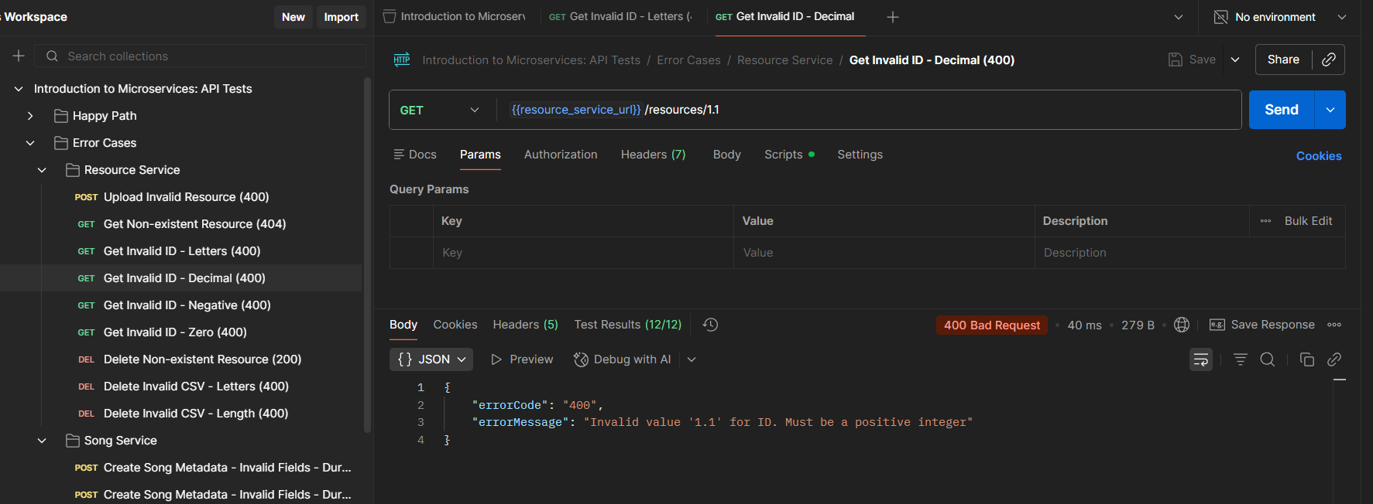

## Get invalid ID - negative (400)

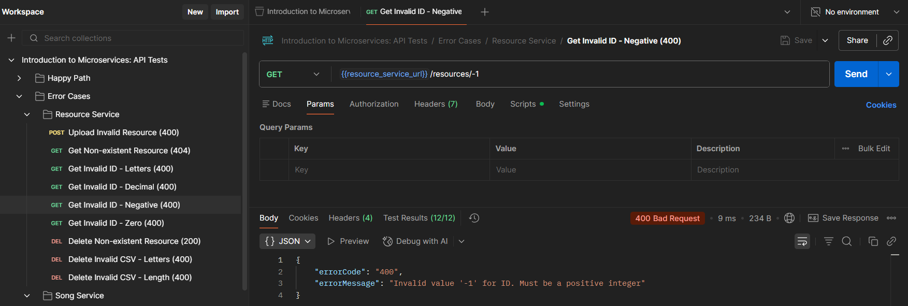

## Get invalid ID - zero (400)

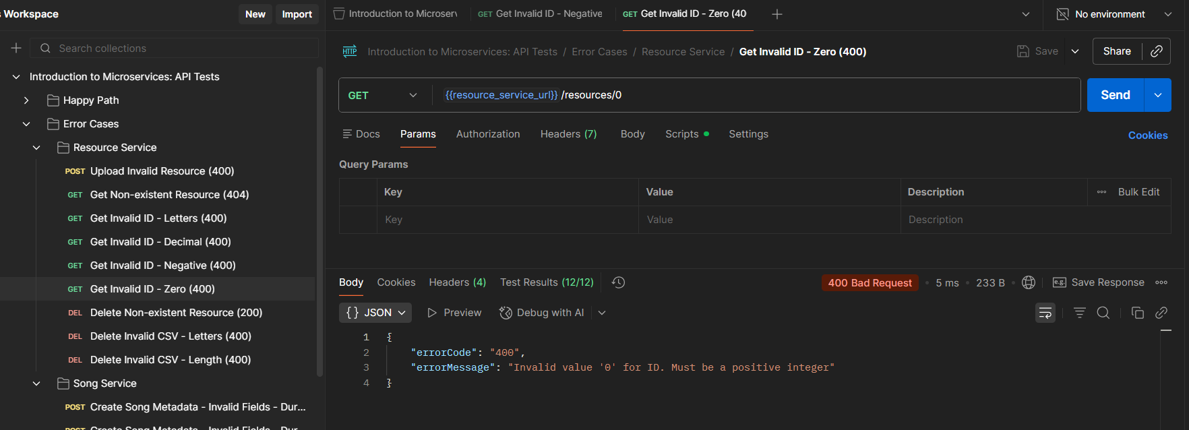

## Delete non-existent resource (200)

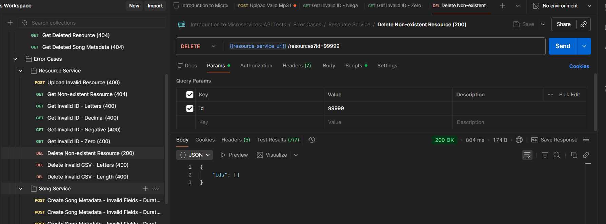

## Delete invalid CSV - letters (400)

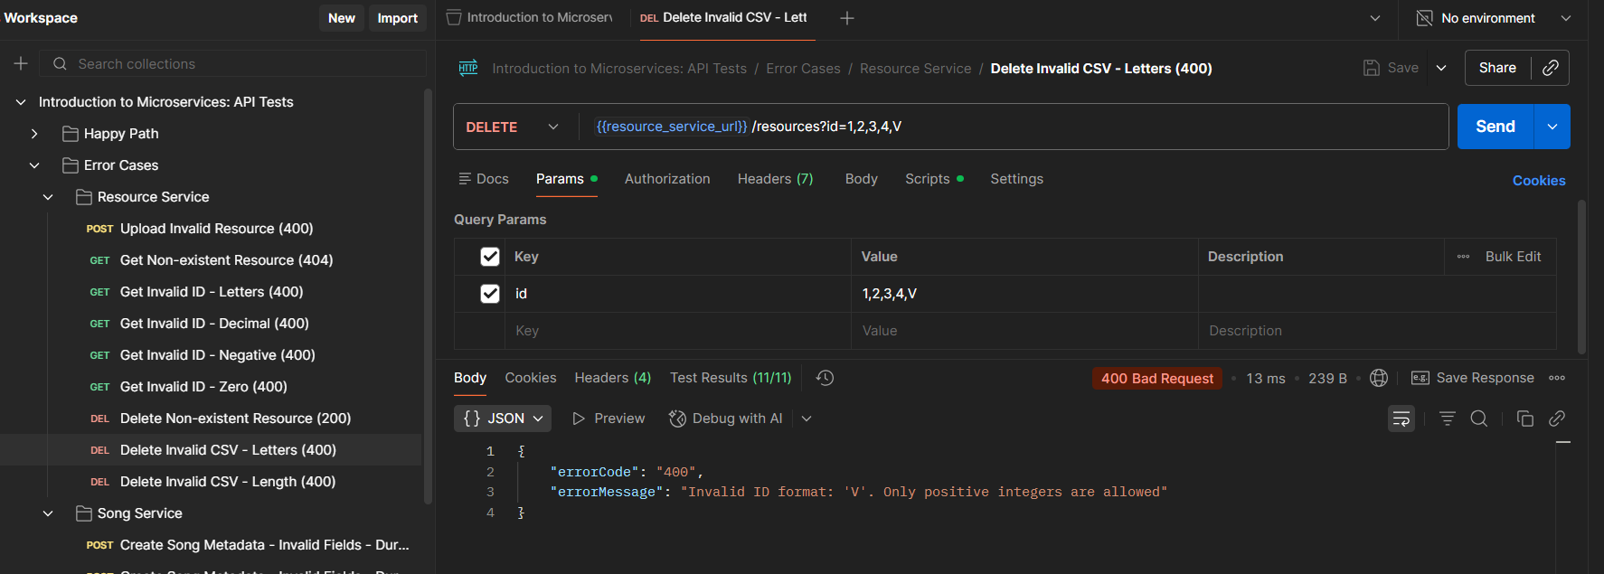

## Delete invalid CSV - length exceeded (400)

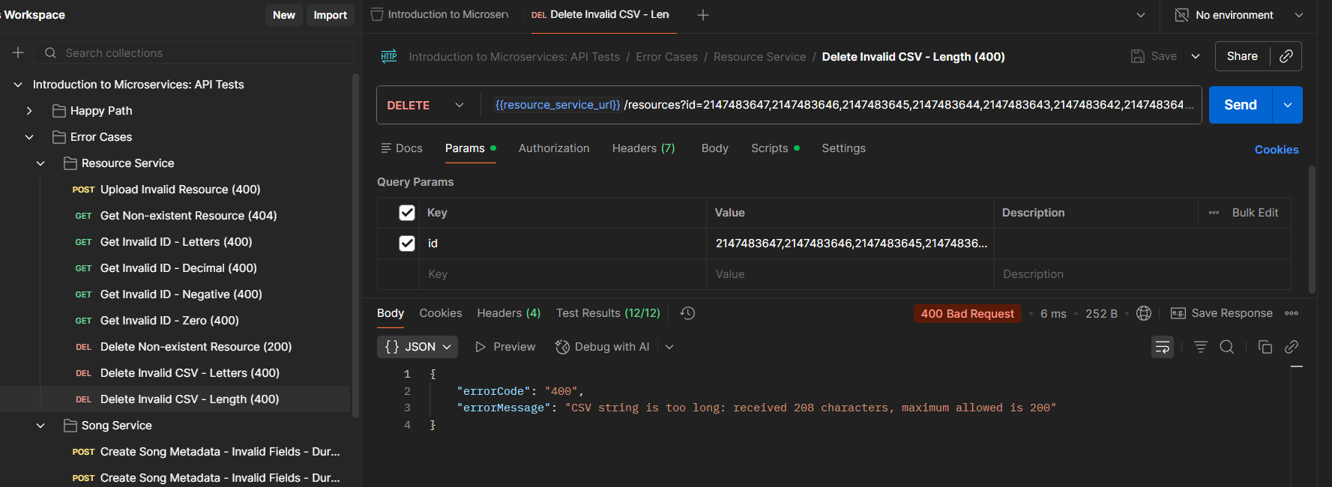

# Error cases: Song Service

## Create song metadata - invalid fields - duration 02:77, year 01977 (400)

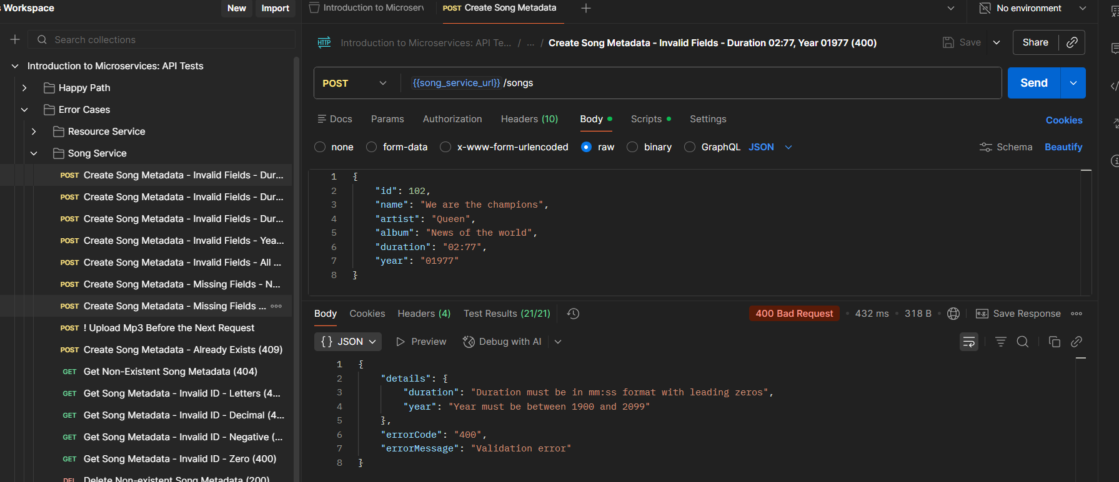

## Create song metadata - invalid fields - duration 0299 (400)

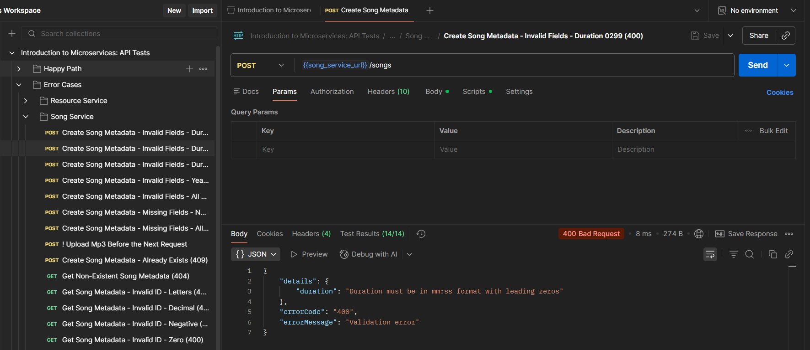

## Create song metadata - invalid fields - duration 35 (400)

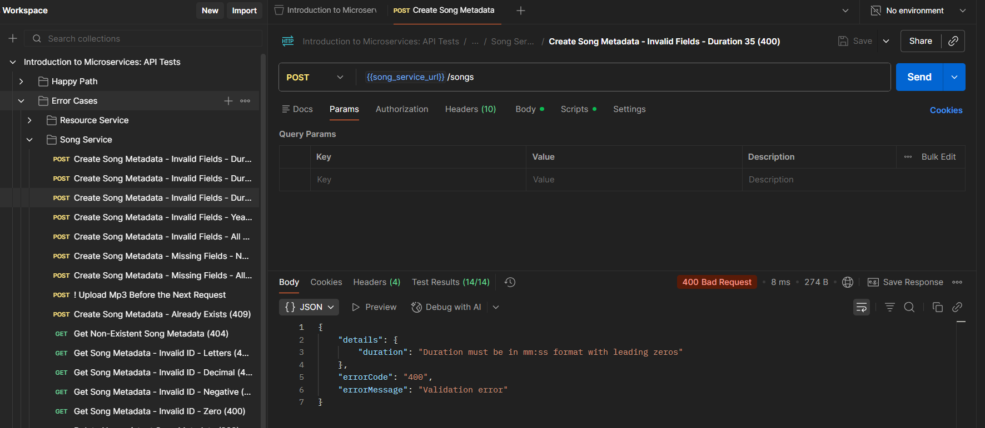

## Create song metadata - invalid fields - year 1 (400)

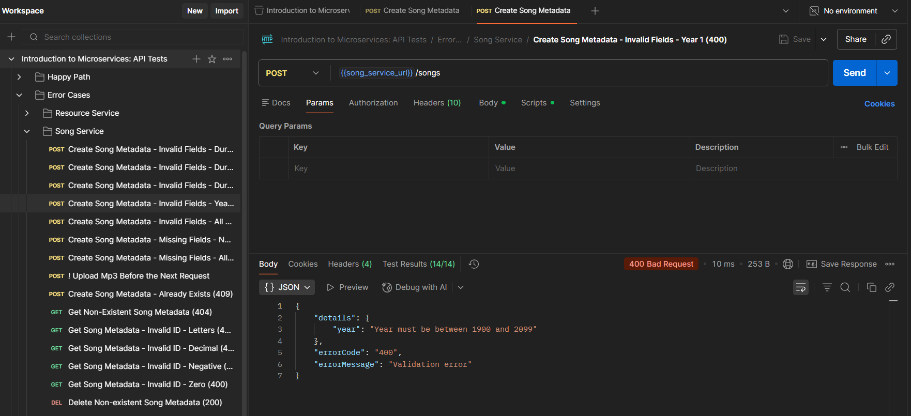

## Create song metadata - invalid fields - all empty (400)

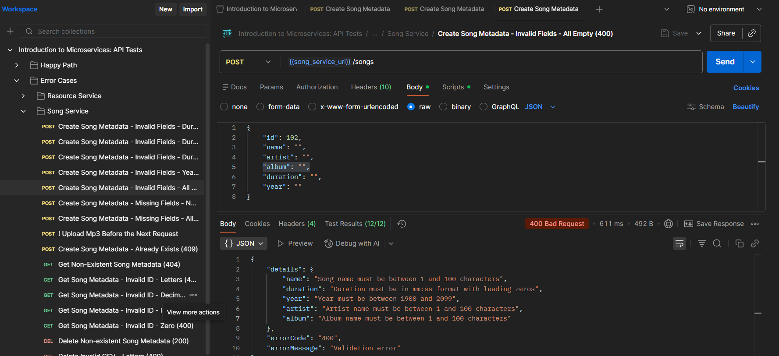

## Create song metadata - missing fields - name (400)

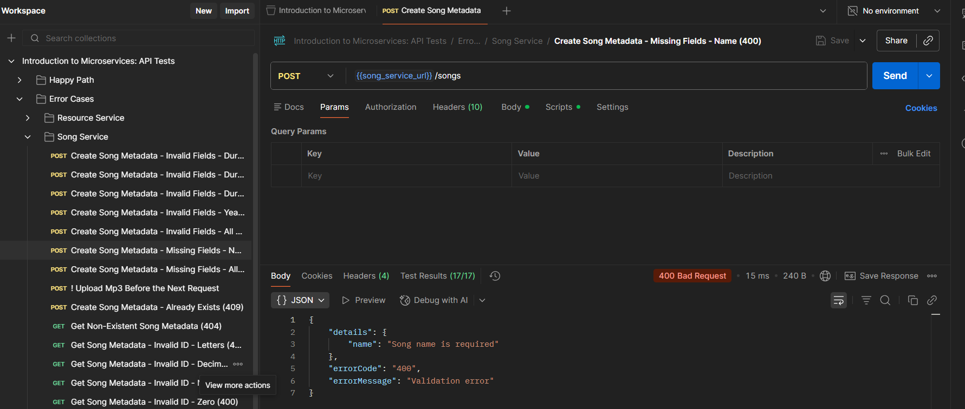

## Create song metadata - missing fields - all except id (400)

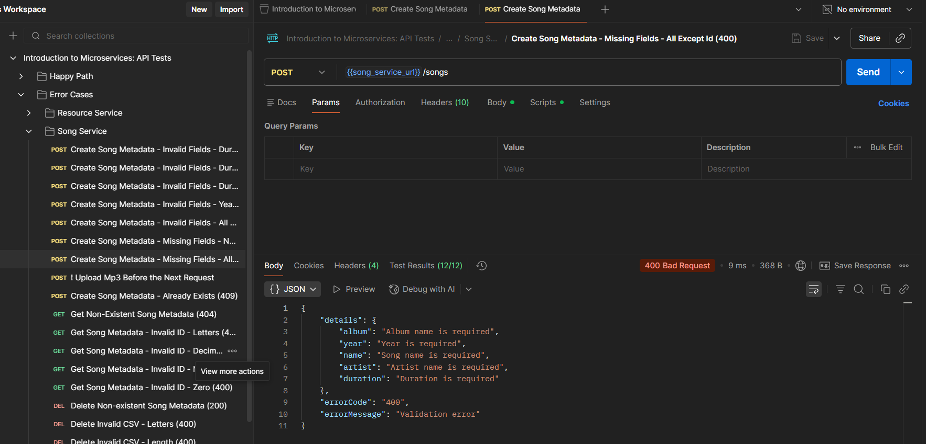

## Create song metadata - already exists (409)

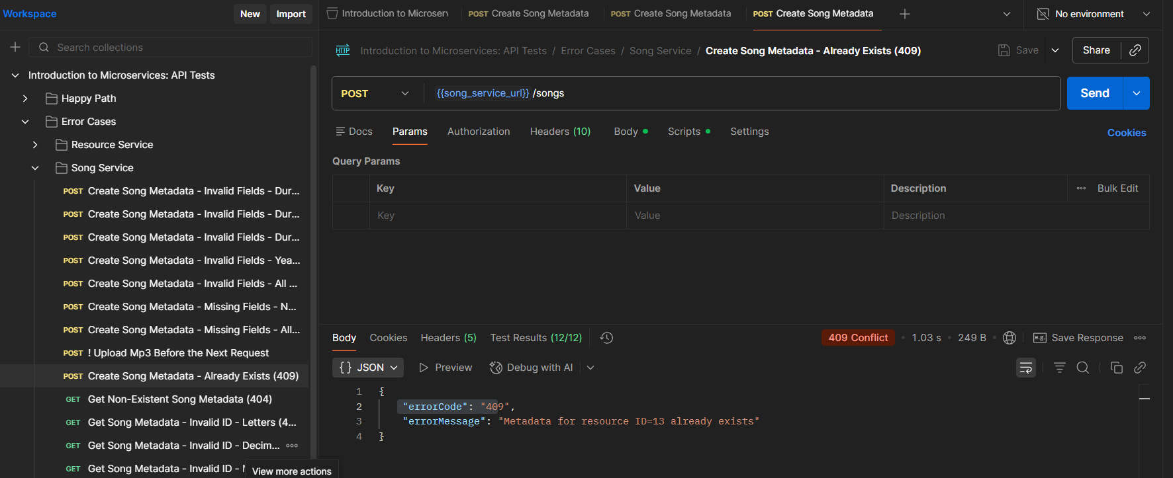

## Get non-existent song metadata (404)

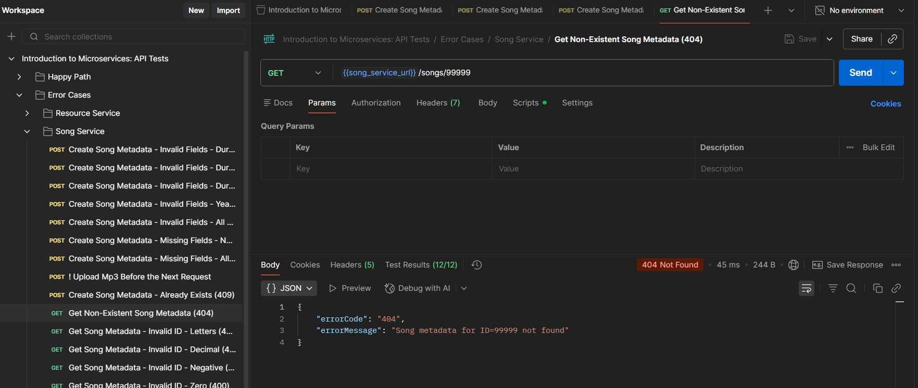

## Get song metadata - invalid ID - letters (400)

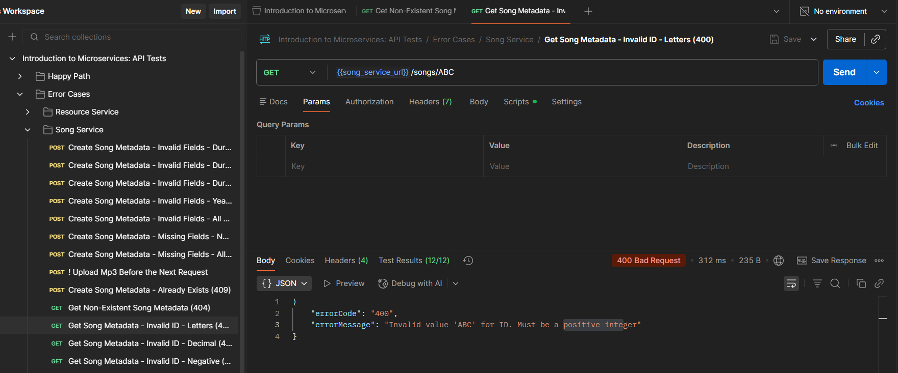

## Get song metadata - invalid ID - decimal (400)

## Get song metadata - invalid ID - negative (400)

## Get song metadata - invalid ID - zero (400)

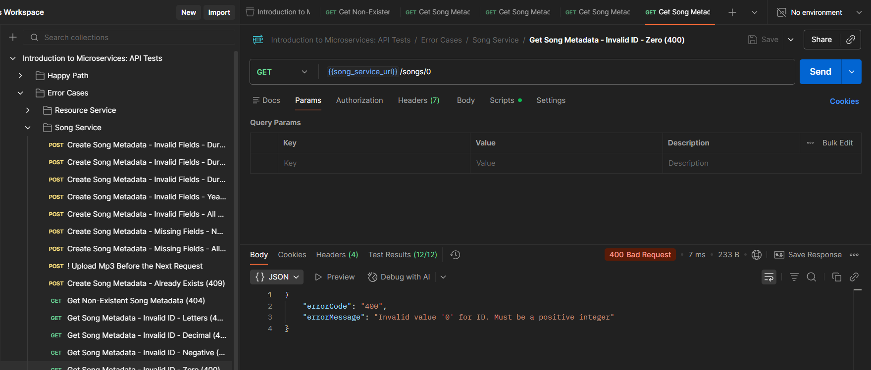

## Delete non-existent song metadata (200)

## Delete invalid song metadata CSV - letters (400)

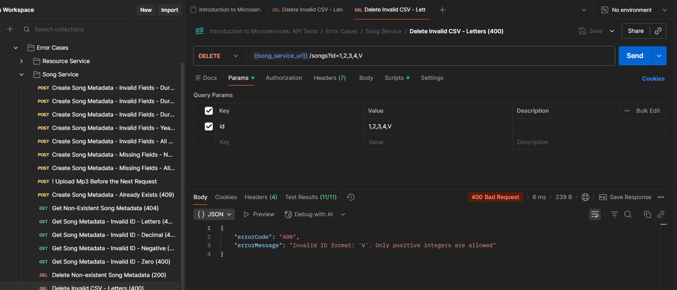

## Delete invalid song metadata CSV - length exceeded (400)

